**Spoon Test: The Midnight Reflection**

**Scene 1: Knock at the Door**

*Background: Dimly lit Filipino kitchen at night, wooden table with a spoon, flickering candlelight.*

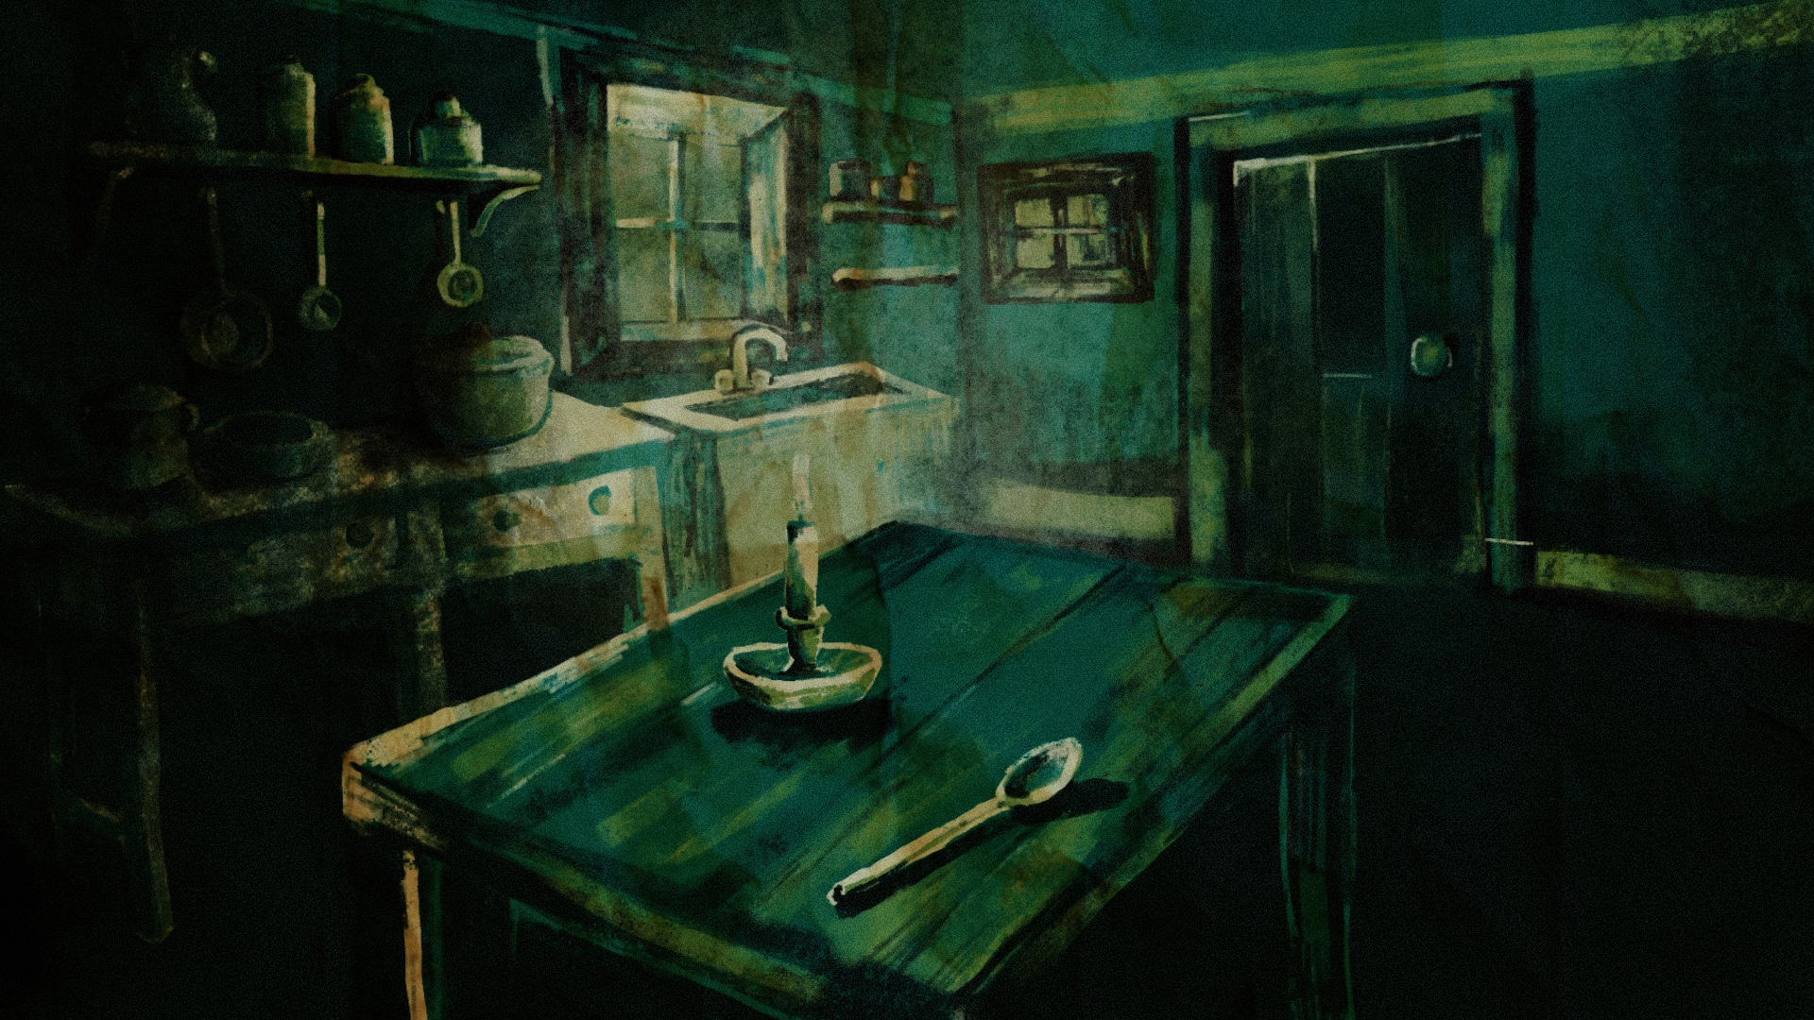

*SFX Distant knocking, creaky wood, faint wind.*

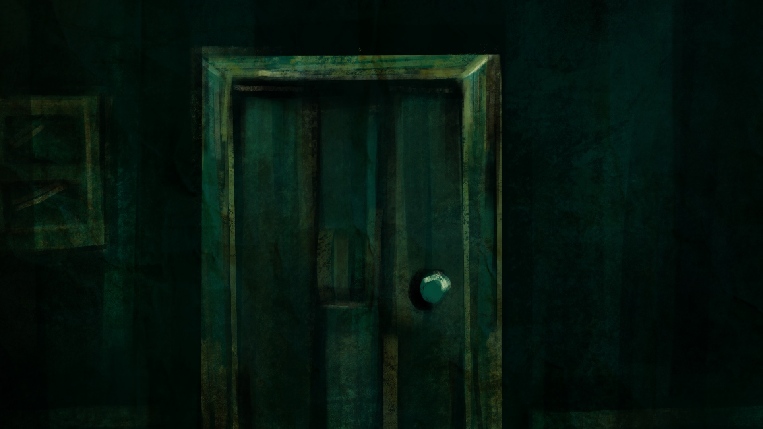

[Player hears a knock at the door. They turn toward the sound.]

Mila (muffled) Hey, open up. It’s me.

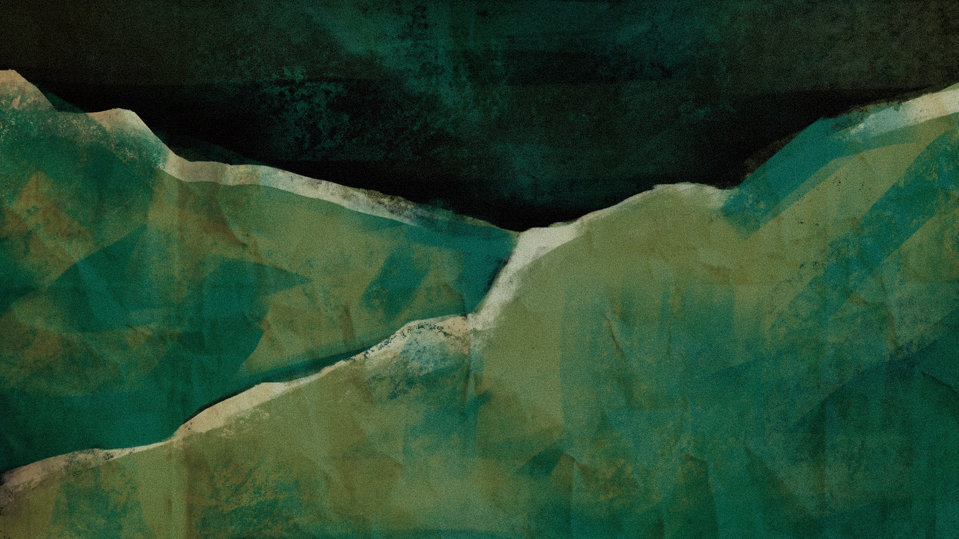

Interaction:

**Option 1** Answer the door.

Leads to Scene 2.

**Option 2** Hesitate.

*Mila knocks again, sounding impatient.*

---

Scene 2: The Spoon Test

*Background: Close-up of wooden table, metal spoon reflecting candlelight.*

*SFX: Spoon clinking, low ambient hum.*

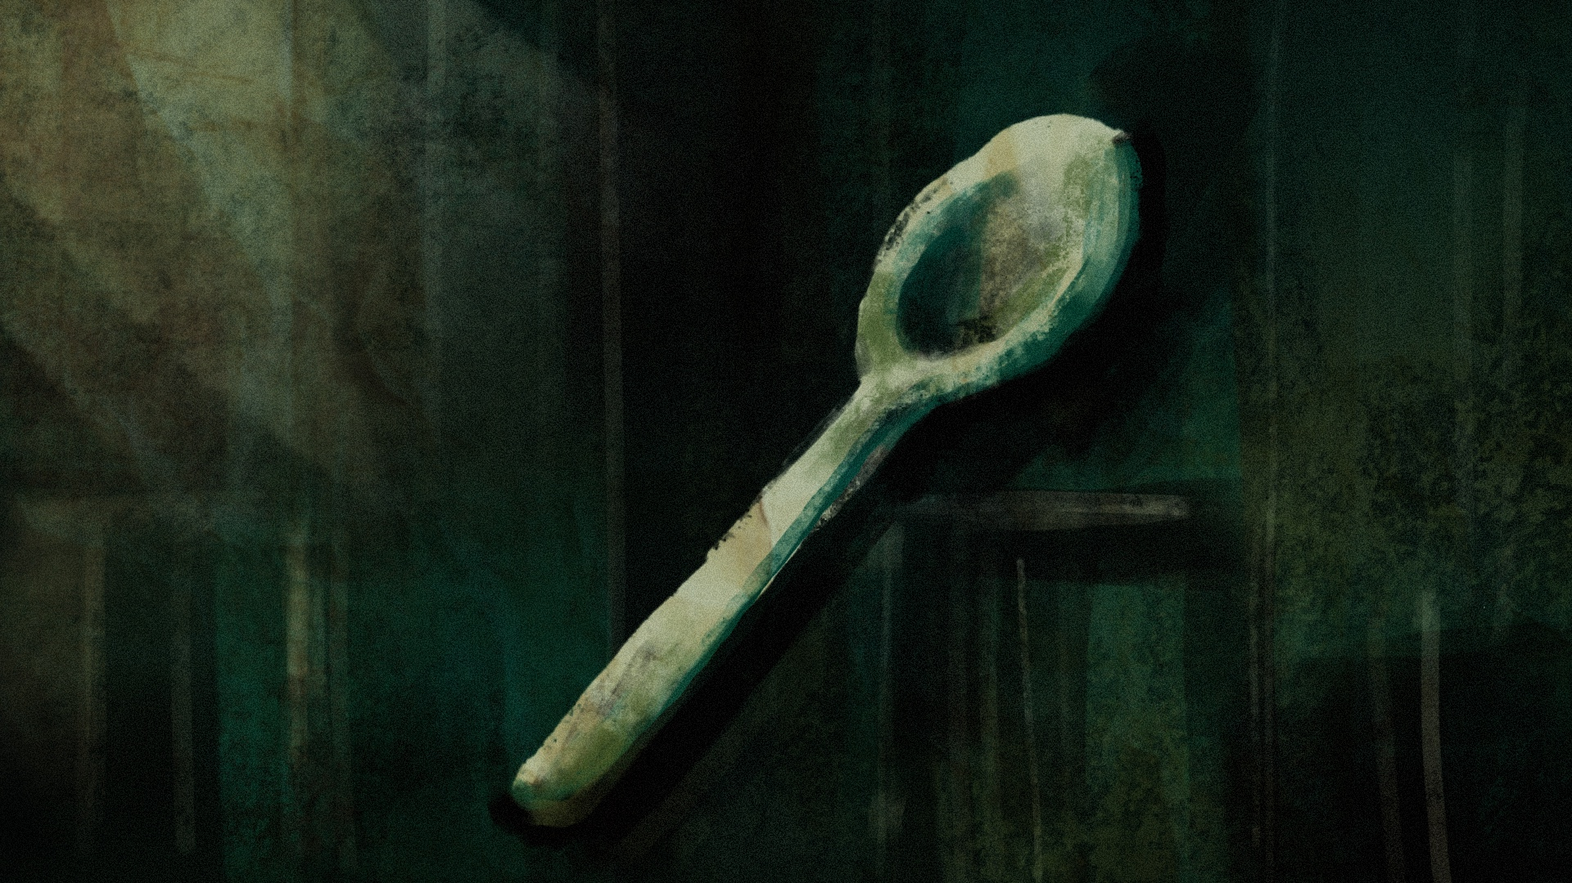

[Player picks up the spoon, inspecting the reflection.]

Interaction:

**Option 1** Pass the spoon to Mila.

Leads to Scene 3.

**Option 2** Check the reflection yourself

Leads to Scene 3 but with more tension.

---

**Scene 3: Reflection Reveal**

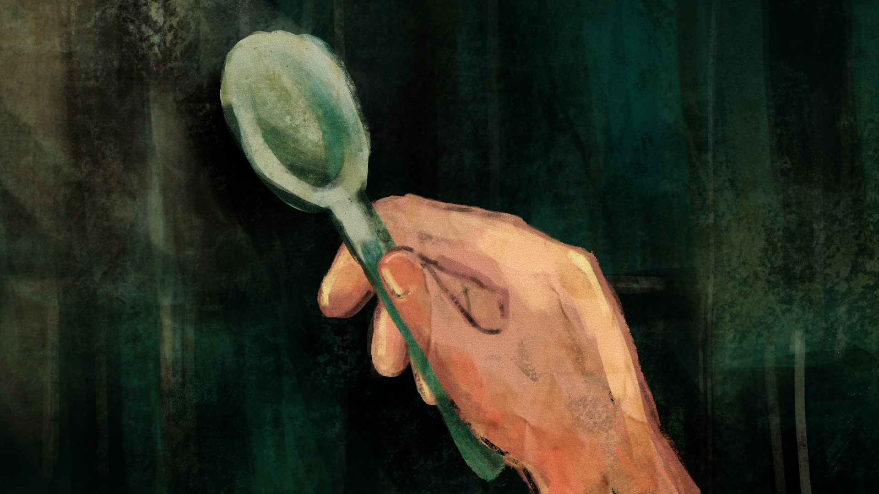

*Background: Extreme close-up of spoon, Mila’s reflection looking slightly off.*

SFX: Subtle distortion sound, heartbeat SFX.

Mila (softly): What’s wrong?

[Player grips the spoon tighter.]

Interaction:

**Option 1** Act normal.

Leads to Scene 4.

**Option 2** Call her out.

Leads to Scene 4 with an aggressive response.

---

**Scene 4: Confrontation**

*Background: Mila grinning unnaturally wide, candlelight flickering.*

*SFX:Low rumbling hum.*

Mila: You figured it out, huh?

Interaction:

**Option 1** Throw salt

*Leads to Scene 5 (good ending).*

**Option 2** Do nothing.

Leads to Scene 5 (bad ending).

---

**Scene 5: Resolution**

*Background: Kitchen, tension breaking.*

*SFX: Loud hiss, salt sizzling, door slamming open.*

**Good Ending:** Mila vanishes, leaving behind an eerie silence.

**Bad Ending:** Everything goes dark…

---

**Smoke Break with a Kapre**

**Scene 1: The Encounter**

*Background: Rural dirt path at night, balete tree hidden in mist.*

*SFX: Night crickets, faint wind.*

[Player notices a faint glowing ember in the tree.]

Interaction

**Option 1** Ignore it.

Leads to looping effect in Scene 3.

**Option 2** Call out.

Leads to Scene 2.

---

**Scene 2: The Kapre Speaks**

*Background: Glowing ember brighter, hinting at a hidden figure.*

*SFX:Low chuckle, rustling leaves.*

Kapre (deep, amused voice): You lost or just curious?

Interaction:

**Option 1** Play it cool.

Leads to Scene 4.

**Option 2** Try to leave.

Leads to looping effect in Scene 3.

---

**Scene 3: The Kapre’s Trick**

*Background: Player turns but finds themselves back at the tree.*

*SFX: Whooshing sound, distant dog bark.*

Interaction:

**Option 1** Acknowledge Kapre.

Leads to Scene 4.

**Option 2** Keep walking.

Loop repeats.

---

**Scene 4: The Lesson**

*Background: Kapre’s silhouette now visible, lounging in the tree.*

*SFX: Soft cigar puff, rustling branches.*

**Kapre:** I mess with people who ignore the land. It’s kinda my thing.

Interaction:

**Option 1** Respectfully listen.

Leads to Scene 5 (good ending).

**Option 2** Dismiss the lesson.

Leads to Scene 5 (bad ending).

---

**Scene 5: Resolution**

Background: Player catches glowing stone OR environment subtly shifts

SFX: Mystical chime, deep chuckle.

**Good Ending:**

Player gains a protective charm against getting lost.

**Bad Ending:**

Player realizes they are lost in a subtly different version of the same place.

---

**Step on a Nuno**

**Scene 1: The Step**

*Background: Rural dirt path, small punso (mound).*

*SFX: Crunch sound, echoed “Hoy!”*

Interaction:

**Option 1** Apologize.

Leads to Scene 2.

**Option 2** Ignore it.

Leads to Scene 3.

---

**Scene 2: The Nuno Appears**

*Background: Tiny, grumpy Nuno emerges from the punso.*

*SFX: Tiny angry muttering, wind gust.*

Interaction:

**Option 1** Offer to fix the mound.

Leads to Scene 4.

**Option 2** Offer food.

Leads to Scene 4.

---

**Scene 3: The Curse**

*Background: Player suddenly scratching, feeling sick.*

*SFX: Desaturate colors, low rumbling sound.*

Interaction:

**Option** 1 Apologize sincerely.

Leads to Scene 4.

**Option 2** Run away.

Leads to bad ending.

---

**Scene 4: Resolution**

*Background: Nuno smugly nodding OR crossing arms.*

*SFX: Chime (if lucky), stomach gurgle (if cursed).*

**Good Ending:**

Player learns to respect nature.

**Bad Ending:**

Player suffers mild but annoying misfortune for days.

---

Spoon Test: The Midnight Reflection

| **Scene** | **Interaction & Decision** | **Background** | **Characters** | **Expressions & Details** | **Camera & Video Effects** | **SFX & Audio** |
| --- | --- | --- | --- | --- | --- | --- |
| 1. Knock at the Door | Player chooses to hesitate or let Mila in | Dim kitchen, candlelight flickering, wooden table with spoon | Mila (shadowy at the door) Player (off-screen) | Mila: Neutral but slightly off Player: Unseen, implied skepticism | Slow Zoom In on Mila | Distant knocking Creaky wood Faint wind |
| 2. The Spoon Test | Player chooses to hand Mila the spoon or check reflection themselves | Same kitchen, candle slightly dimmer | Mila (closer, looking at spoon) Player (holding spoon) | Mila: Hesitant Player: Curious, testing | Extreme Close-Up of spoon reflection | Spoon clinking Low ambient hum |
| 3. Reflection Reveal | Player sees distorted reflection | Close-up of spoon reflection | Mila (reflection is blurry/distorted) Player (visible in reflection, shocked) | Mila: Unnatural grin Player: Startled, sweating | Glitch Effect + Camera Shake | Subtle distortion sound Heartbeat SFX |
| 4. Confrontation | Player chooses to act normal or call her out | Darkened kitchen | Mila (grinning unnaturally wide) Player (nervous) | Mila: Eerie grin Player: Tense | Slow Zoom In on Mila’s face | Low rumbling hum |
| 5. Attack or Escape | Player throws salt or calls for Lola | Same kitchen OR door swinging open | Mila (lunging forward) Player (throwing salt) Lola (if applicable) | Mila: Screeching Player: Panicked Lola: Stern, holding salt | Quick Zoom Out + Camera Shake (if attacked) Flash Transition (if defeated) | Loud hiss Salt sizzling Door slamming open |

Smoke Break with a Kapre

| **Scene** | **Interaction & Decision** | **Background** | **Characters** | **Expressions & Details** | **Camera & Video Effects** | **SFX & Audio** |
| --- | --- | --- | --- | --- | --- | --- |
| 1. First Encounter | Player reacts to seeing glowing ember | Empty lot, giant balete tree, soft mist | Kapre (shadowy figure in tree) Player (off-screen) | Kapre: Smirking, cigar ember glowing | Low Angle Slow Zoom In on Kapre | Soft crickets Low ambient hum |
| 2. The Kapre’s Trick | Player tries to run or talk to Kapre | Looping street (player runs but ends up back at tree) | Kapre (laughing, arms crossed) Player (panting, confused) | Kapre: Grinning, shaking head Player: Sweating, confused | Quick Cut (loop effect) Slight Camera Shake (disorienting effect) | Footsteps running Whooshing effect |
| 3. Lesson on Respect | Player chooses to respect nature or dismiss it | Balete tree, mystical lighting | Kapre (leaning back, smoking) Player (listening) | Kapre: Smirking Player: Thoughtful | Slow Cigar Smoke Overlay Medium Shot Panning | Deep, amused chuckle Soft wind |
| 4. Final Judgment | Kapre rewards player or curses them | Same tree OR altered, eerie street | Kapre (giving player a stone) Player (accepting or looking horrified) | Kapre: Nodding approvingly OR smirking mischievously Player: Relieved OR distressed | Desaturate Colors + Low-Rumbling Sound (if cursed) | Faint mystical chime Deep echoing laughter |

Step on a Nuno

| **Scene** | **Interaction & Decision** | **Background** | **Characters** | **Expressions & Details** | **Camera & Video Effects** | **SFX & Audio** |
| --- | --- | --- | --- | --- | --- | --- |
| 1. The Step | Player unknowingly steps on the mound | Dirt path, trees, small punso (mound) | Player (off-screen) Nuno (invisible) | Player: Mid-step, oblivious | Quick Zoom In on foot stepping | Crunch sound Echoed “Hoy!” |
| 2. The Nuno Appears | Player chooses to apologize or ignore | Same dirt path, slightly dimmer | Nuno (angry, arms crossed) Player (looking nervous) | Nuno: Fuming, tiny hands on hips Player: Sweating | Quick Zoom on Nuno’s angry face | Tiny angry muttering Wind gust |
| 3. The Bargain | Player offers to fix the mound or give food | Same setting, slight shift in angle | Nuno (suspicious, tapping chin) Player (awkward) | Nuno: Curious OR skeptical Player: Nervous smile | Slow Zoom Out (for tension) | Light grumble sound |
| 4. The Resolution | Player is forgiven or cursed | Same setting, but brighter if forgiven OR darker if cursed | Nuno (smug) Player (relieved OR cursed and itching) | Nuno: Grinning OR shaking head Player: Sighing in relief OR scratching | Flash Transition (if cursed) OR Soft Fade Out (if forgiven) | Chime (if lucky) Stomach gurgle (if cursed) |

Video Editing Guidelines

• Use Slow Zooms for Suspense (Spoon Test reflection, Kapre first reveal).

• Quick Cuts for Comedy & Sudden Realization (Player stepping on the Nuno, Spoon Test glitch moment).

• Desaturate & Add Low Rumbling for Cursed Endings (Kapre trick, Nuno punishment).

• Use Flash Transitions for Supernatural Moments (Salt thrown at Aswang, Kapre disappearing).

• Layer Ambient SFX Loops for Depth (Night crickets, faint wind, occasional distant dog barking).

This table keeps everything structured and easy to animate, ensuring smooth storytelling and immersive visual effects. Would you like any refinements, additional scenes, or alternative effects?